**Lab 4: Prolog – AI Techniques**

1. Write production rules to solve Water jug problem using Python or Prolog.

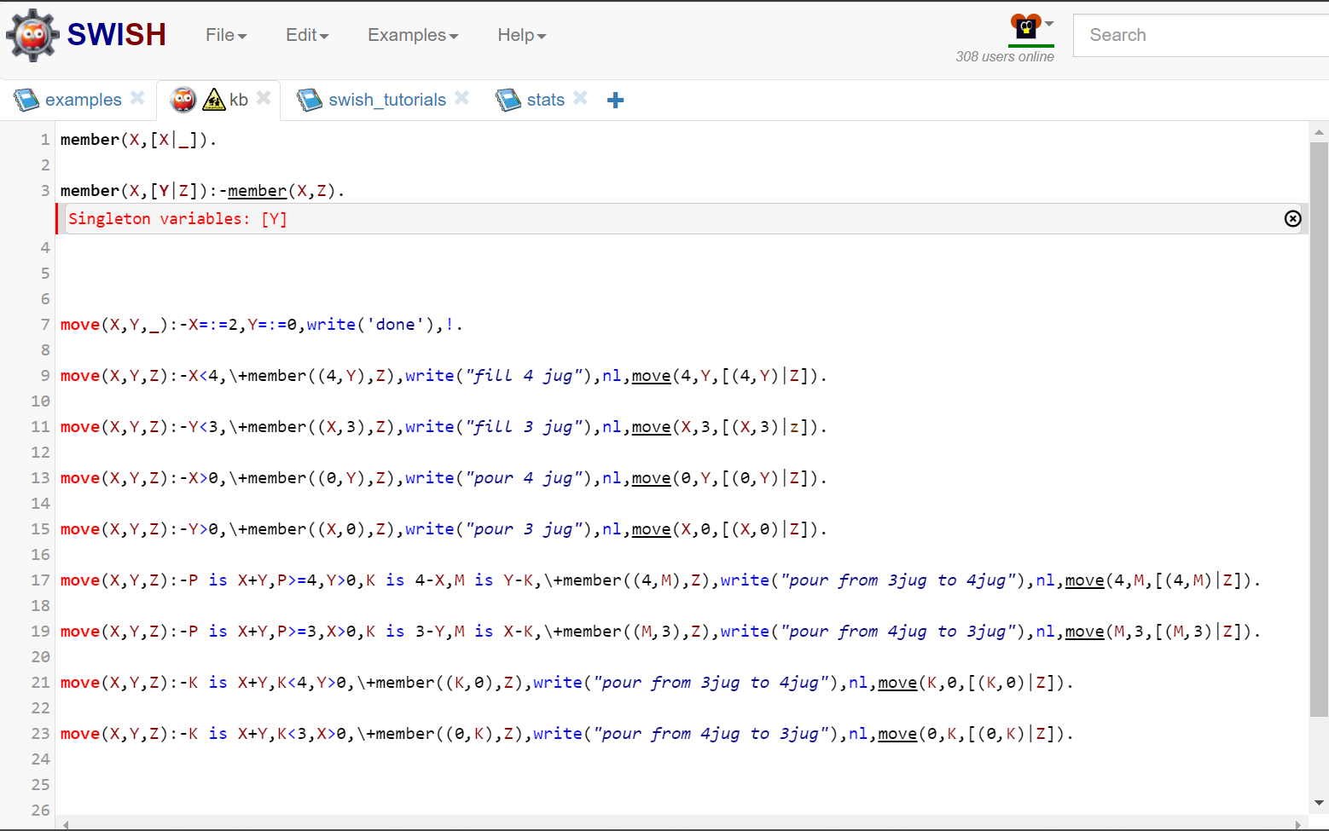

Output:

1. Write a Program to solve Money banana problem using PROLOG.

Suppose the problem is as given below −

* A hungry monkey is in a room, and he is near the door.
* The monkey is on the floor.
* Bananas have been hung from the center of the ceiling of the room.
* There is a block (or chair) present in the room near the window.
* The monkey wants the banana, but cannot reach it.

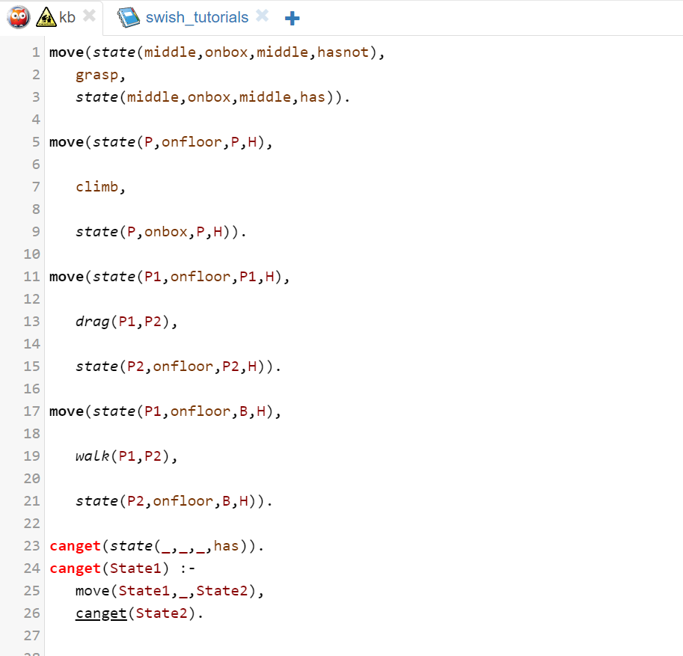

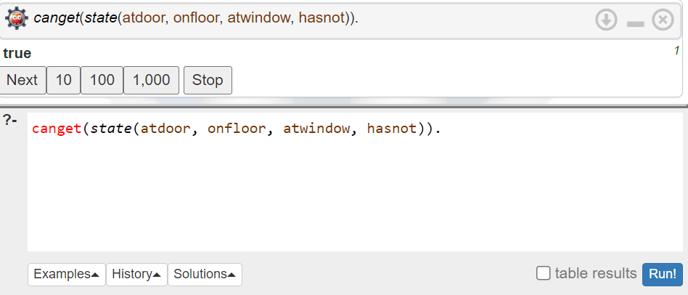**Output:**